**Project Initialization and Planning Phase**

| Date | 6 October 2025 |
| --- | --- |
| Team ID | SWUID20250197150 |
| Project Name | Global Food Production Trends and Analysis (1961 – 2023) |
| Maximum Marks | 3 Marks |

**Define Problem Statements (Customer Problem Statement Template):**

Create a problem statement to understand your customer's point of view. The Customer Problem Statement template helps you focus on what matters to create experiences people will love. A well-articulated customer problem statement allows you and your team to find the ideal solution for your customers' challenges. Throughout the process, you’ll also be able to empathize with your customers, which helps you better understand how they perceive your product or service.

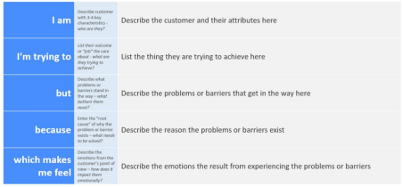

Reference: https://miro.com/templates/customer-problem-statement/

**Example:**



|  |  |  |  |  |  |
| --- | --- | --- | --- | --- | --- |
| **Problem**  **Statement (PS)** | **I am**  **(Customer)** | **I’m trying to** | **But** | **Because** | **Which makes me feel** |
| PS-1 | A researcher or policymaker | Analyze global food production trends over time | The data is scattered across multiple sources and hard to interpret | There’s no clear visualization showing patterns and insights | Frustrated and unable to make data-driven decisions |
| PS-2 | A student or data analyst | Understand how food production has changed by country and crop type | The raw datasets are large and complex | They require cleaning and visualization better understanding | Confused and overwhelmed by unorganized data |